SOFTWARE REQUIREMENTS SPECIFICATION
Financial Ledger
Team QUASAR
A double-entry digital wallet and ledger API

VERSION 1.2
PREPARED BY Team QUASAR
TEAM MEMBERS Suhasini M [BT2024043], Geethika M[BT2024139], Akshaya A [BT2024215]
COURSE Software Engineering — Course Project
DATE 9 November 2026

Revision History
Name | Date | Reason for changes | Version
Team QUASAR | 09-Nov-2026 | Initial baseline for Stage 1 (Requirements). | 1.0
Team QUASAR | 09-Nov-2026 | Condensed; removed redundant and non-essential requirements; restyled. | 1.1
Team QUASAR | 09-Nov-2026 | Relaxed performance targets; marked merchant and admin statistics as Low priority; adjusted test-coverage target. | 1.2

Table of Contents
1. Introduction 1
1.1 Purpose 1
1.2 Document Conventions 1
1.3 Intended Audience and Reading Suggestions 1
1.4 Product Scope 1
1.5 References 1
2. Overall Description 2
2.1 Product Perspective 2
2.2 Product Functions 2
2.3 User Classes and Characteristics 2
2.4 Operating Environment 3
2.5 Design and Implementation Constraints 3
2.6 User Documentation 3
2.7 Assumptions and Dependencies 3
3. External Interface Requirements 3
3.1 User Interfaces 3
3.2 Hardware Interfaces 4
3.3 Software Interfaces 4
3.4 Communications Interfaces 4
4. System Features 5
4.1 User Registration and Authentication 5
4.2 Wallet Initialization and Management 6
4.3 Idempotent Fund Transfers 6
4.4 Merchant Payments 8
4.5 Concurrent Transaction Processing 8
4.6 Double-Entry Ledger and Immutable Audit Trail 9
4.7 Ledger Reconciliation 10
4.8 Administrative Management 11
5. Other Nonfunctional Requirements 12
5.1 Performance Requirements 12
5.2 Safety Requirements 12
5.3 Security Requirements 12
5.4 Software Quality Attributes 13
5.5 Business Rules 13
6. Other Requirements 14
6.1 Database Requirements 14
6.2 Accounting Requirements 14
6.3 Skill Requirements 15
6.4 Requirements Traceability Matrix 16
Appendix A: Glossary 16
Appendix B: Analysis Models 17
B.1 Use Case Diagram 17
B.2 High-Level System Architecture 18
B.3 Entity Relationship Diagram 19
B.4 Transaction Lifecycle (Activity Diagram) 20
Appendix C: To Be Determined List 21

1. Introduction

1.1 Purpose
This Software Requirements Specification (SRS) defines Release 1.0 of Financial Ledger – Team QUASAR, a simplified digital wallet backed by a double-entry ledger, built for an undergraduate Software Engineering course. It covers the REST API, the SQLite ledger, the minimal React interface and the two verification skills. As required by SE-1 of the course SDLC [R2], it contains functional (FR), nonfunctional (NFR) and skill (SK) requirements, and it is the Stage 1 baseline for design, testing and the final demonstration.

1.2 Document Conventions
- "The system shall" marks a mandatory, testable requirement. Every requirement has a unique ID: FR (functional), NFR (nonfunctional), UI, BR (business rule), DB, ACC (accounting), SK (skill).
- The "Traces to" column cites the assignment's original requirements FR-1 to FR-5, its testing requirements TQ-1 to TQ-6, or Scope (the three-role definition). Section 6.4 holds the full traceability matrix.
- Feature priorities (High/Medium/Low) are inherited by the requirements within each feature.
- Money is shown as ₹ with Indian grouping (₹1,00,000.00) but is always stored and sent as integer paise (amountMinor); ₹1,000.00 = 1,00,000 paise.
- Monospace marks API paths, headers, statuses and error codes. Named mechanisms (e.g., BEGIN IMMEDIATE) are proposed design; the requirement is the observable behaviour.

1.3 Intended Audience and Reading Suggestions
Evaluators should read Sections 1, 2 and 4, then the traceability matrix (6.4). Developers should read Sections 2–6 and Appendix B. Testers should focus on the stimulus/response tables in Section 4, the acceptance criteria in Section 5 and the skills in Section 6.3. Readers new to double-entry bookkeeping should read Section 6.2 first.

1.4 Product Scope
The project statement calls the problem the "vanishing money glitch": in naive systems, simultaneous updates overwrite each other and network retries cause double charges. This product treats money as a verifiable record instead. Its goal is to demonstrate ACID transactions, data integrity, idempotency and clean API design through a ledger that is mathematically consistent.
What the system guarantees
Every completed transaction has total debits = total credits · concurrent requests never corrupt balances · a retried request never transfers twice · committed ledger entries are never changed (corrections are reversals) · recorded balances can always be reconciled against the ledger · every financial operation is atomic.

There are exactly three roles: User, Merchant and Admin. All money is simulated and enters only through admin test funding; the system has no link to any real bank or payment network. This is an academic project, not a production banking system.

1.5 References
Ref. | Document | Source
[R1] | Project Statement: Financial Ledger & Digital Wallet API | Project_2_Financial_Ledger.pdf (course)
[R2] | The AI-Assisted Software Development Life Cycle (SDLC) | SDLC_and_Workflow.pdf (course)
[R3] | K. E. Wiegers, Software Requirements Specification Template (1999) | srs_template-ieee.doc (course)
[R4] | IEEE Std 830-1998, Recommended Practice for SRS | IEEE Standards Association
[R5] | SQLite: Transactions; Write-Ahead Logging; Locking | sqlite.org/lang_transaction.html · sqlite.org/wal.html · sqlite.org/lockingv3.html
[R6] | RFC 7519 JSON Web Token; RFC 9110 HTTP Semantics | rfc-editor.org
[R7] | IETF draft: The Idempotency-Key HTTP Header Field | datatracker.ietf.org/doc/draft-ietf-httpapi-idempotency-key-header

2. Overall Description

2.1 Product Perspective
A new, self-contained product built as a modular monolith: one Spring Boot process with internal modules, owning one SQLite database file (Figure B-2). Clients (the React interface, Postman, JMeter and the skills) call a versioned JSON API at /api/v1. Requests pass through JWT authentication and role checks, then controllers, domain modules (Auth, Wallet, Transfer & Payment, Idempotency, Ledger, Reconciliation, Admin) and a repository layer that runs each financial operation as one database transaction. There are no external system interfaces.

2.2 Product Functions
Function | Summary | Req.
Registration & authentication | Users and merchants register; all roles log in with JWT; role and ownership checks on every call. | Scope
Wallets | One wallet per currency per owner, always backed by ledger entries; admin test funding. | FR-1
Idempotent transfers | User-to-user transfers that require an Idempotency-Key; retries never double-charge. | FR-2
Merchant payments | Users pay merchants; merchants see payments and simple statistics. | FR-1, 2
Concurrency control | Simultaneous operations on one wallet are serialized; no lost updates or negative balances. | FR-3
Ledger & audit trail | Balanced, append-only entries; corrections by reversal; transaction history. | FR-1, 4
Reconciliation | Read-only check that debits = credits and balances match the ledger. | FR-5
Administration | View all records; freeze, unfreeze or deactivate wallets; platform statistics. | Scope

2.3 User Classes and Characteristics
Role | Characteristics | Permitted operations
User (USER) | Individual wallet owner; most frequent and most important class; no technical skill assumed. | Register, log in; create and view own wallets and balances; transfer to other users; pay merchants; view own history and transaction details.
Merchant (MERCHANT) | Business that receives payments; cannot send money. | Register, log in; view merchant account; receive payments; view payment history and statistics.
Admin (ADMIN) | Team member operating the platform; provisioned by configuration only; cannot edit balances directly. | Log in; view users, merchants, wallets, transactions and ledger entries; run reconciliation; freeze/unfreeze/deactivate wallets; record test funding; reverse transactions; view statistics.

No other roles exist. Users and merchants can never see another party's private financial records.

2.4 Operating Environment
- Backend: Java 17+ with Spring Boot 3.x, single process on Windows, macOS or Linux.
- Database: SQLite 3 via sqlite-jdbc; one file on a local disk in WAL mode; in-memory or temporary databases for tests.
- Frontend: React single-page app in current Chrome, Firefox or Edge.
- Reference machine (for Section 5.1 targets): 4-core CPU, 8 GB RAM, SSD; server, database and load generator on one machine.

2.5 Design and Implementation Constraints
- Java + Spring Boot, RESTful JSON API, Spring Security with JWT, minimal React frontend, modular monolith with one centralized database.
- SQLite is mandatory for this release, as encouraged by [R1]. Atomicity uses SQLite transactions (BEGIN, COMMIT, ROLLBACK); concurrency uses WAL mode and transaction locking, with no distributed lock server.
- SQLite allows one writer at a time; the design serializes writes and does not assume parallel writes. Readers run alongside the writer in WAL mode.
- Exactly one application instance may use the database file.
- Money is never stored or calculated with floating-point types (TQ-6).
- No integration with any real bank, payment network or gateway.

2.6 User Documentation
Delivered with the software (SE-7 [R2]): a README covering setup, configuration and running; an OpenAPI 3 specification with Swagger UI; a short user guide for each role; and a Postman collection including negative and idempotency cases.

2.7 Assumptions and Dependencies
- Single machine, local disk (WAL mode does not work on network file systems [R5]).
- INR is mandatory; other currencies are configurable (TBD-1). There is no currency conversion.
- Clients that retry after a timeout reuse the original idempotency key; the provided frontend does (UI-04).
- Demonstration scale: about 1,000 accounts and 1,00,000 ledger entries. All timestamps are UTC.

3. External Interface Requirements

3.1 User Interfaces
A minimal React app with a top bar (product name, account name, Logout) and role-specific navigation. User: Dashboard (wallets and balances, create wallet), Transfer, Pay Merchant, History & Detail. Merchant: Account, Payments, Statistics. Admin: Users & Merchants, Wallets (status and test-funding actions), Transactions & Ledger (reversal action), Reconciliation, Statistics.
ID | Requirement | Traces to
UI-01 | The interface shall show amounts with ₹ symbol, Indian grouping and two decimals. | BR-01
UI-02 | The interface shall convert entered rupee amounts to integer paise by exact string parsing and reject more than two decimal places. | TQ-6
UI-03 | The interface shall show only the screens permitted for the logged-in role and shall map every error code to a readable message. | Scope
UI-04 | The interface shall create a new UUID idempotency key for each new financial submission and reuse it when the user retries after a network error, timeout or HTTP 503. | FR-2
UI-05 | The interface shall disable the submit button while a financial request is in progress. | FR-2

3.2 Hardware Interfaces
None. The system runs on commodity PCs and uses hardware only through the OS, JVM and SQLite. Durable local storage is covered by NFR-SAFE-04.

3.3 Software Interfaces
SQLite through JDBC (configuration in Section 6.1); Spring Web for HTTP and JSON; Spring Security with a JWT library and BCrypt; springdoc-openapi for API docs. JUnit 5, Mockito, Postman and JMeter are test tools only. Table 3-1 lists the endpoints (all under /api/v1; ★ = requires Idempotency-Key).
Table 3-1: API endpoints and role authorization
Role | Endpoints
Public | POST /auth/register · POST /auth/register/merchant · POST /auth/login · GET /health
USER | POST /wallets · GET /wallets · GET /wallets/{id} · POST /transfers ★ · POST /payments ★ · GET /transactions · GET /transactions/{id}
MERCHANT | GET /merchant/account · GET /merchant/transactions · GET /merchant/statistics
ADMIN | GET /admin/users · GET /admin/merchants · GET /admin/accounts · GET /admin/accounts/{id}/entries · GET /admin/transactions · GET /admin/transactions/{id} · POST /admin/wallets/{id}/freeze | unfreeze | deactivate · POST /admin/wallets/{id}/test-funding ★ · POST /admin/transactions/{id}/reversal ★ · POST /admin/reconciliations · GET /admin/statistics

3.4 Communications Interfaces
HTTP/1.1 with UTF-8 JSON bodies; HTTPS for anything beyond localhost. Headers: Authorization: Bearer <JWT>, Idempotency-Key, and on responses Idempotent-Replayed: true (replays) and Retry-After (HTTP 503). Amounts are JSON integers (amountMinor); timestamps are ISO-8601 UTC. Lists accept page and size (default 20, max 100). Every error returns code, message, timestamp, path and requestId.
Table 3-2: Error codes
HTTP | Code — meaning
400 | VALIDATION_ERROR — malformed JSON, ID, field, key or amount · IDEMPOTENCY_KEY_REQUIRED — header missing
401 / 403 / 404 | UNAUTHENTICATED — bad login or token · FORBIDDEN — role not allowed · NOT_FOUND — missing or not yours
409 | DUPLICATE_RESOURCE — email or wallet exists · IDEMPOTENCY_KEY_REUSED — same key, different payload · ALREADY_REVERSED · INVALID_STATE_TRANSITION
422 | INSUFFICIENT_FUNDS · WALLET_NOT_ACTIVE · CURRENCY_MISMATCH · SAME_WALLET · INVALID_DESTINATION · NOT_REVERSIBLE
500 / 503 | INTERNAL_ERROR — rolled back, no partial effect · SERVICE_BUSY — write lock timeout, safe to retry with same key

4. System Features
Each feature lists its priority, key positive and negative scenarios, and its functional requirements. The running example uses Asha (wallet W-1001), Ravi (W-1002) and merchant Campus Café (code MER-7Q2K9D, wallet W-2001), all INR.

4.1 User Registration and Authentication

4.1.1 Description and Priority
High. Users and merchants self-register; admins come from configuration. Login returns a signed JWT. Role checks and ownership checks protect every operation.

4.1.2 Stimulus/Response Sequences
# | Stimulus | System response
1 | Visitor registers as a merchant ("Campus Café"). | Account, unique merchant code and an ACTIVE INR wallet (₹0.00) are created. HTTP 201.
2 | Registration with an existing email (any letter case). | HTTP 409 DUPLICATE_RESOURCE.
3 | Login with a wrong password or an unknown email. | HTTP 401 with the same generic message in both cases.
4 | Unauthorized access: a USER token calls GET /admin/transactions. | HTTP 403 FORBIDDEN.
5 | Unauthorized access: Asha requests GET /wallets/W-1002 (Ravi's wallet). | HTTP 404 NOT_FOUND; the wallet's existence is not revealed.

4.1.3 Functional Requirements
ID | Requirement | Traces to
FR-AUTH-01 | The system shall let a visitor register a USER account with display name, email and password. | Scope
FR-AUTH-02 | The system shall let a visitor register a MERCHANT account with business name, email and password, and assign a unique merchant code. | Scope
FR-AUTH-03 | The system shall reject an already-registered email (case-insensitive) with HTTP 409 DUPLICATE_RESOURCE. | Scope
FR-AUTH-04 | The system shall reject passwords shorter than 8 or longer than 72 characters with HTTP 400. | Scope
FR-AUTH-05 | The system shall create ADMIN accounts only from deployment configuration, never through the API. | Scope
FR-AUTH-06 | The system shall issue a signed JWT with account ID, role and expiry on successful login, and return a generic HTTP 401 on any failed login. | Scope
FR-AUTH-07 | The system shall reject a missing, invalid or expired token with HTTP 401. | Scope
FR-AUTH-08 | The system shall allow each endpoint only for the roles in Table 3-1 and return HTTP 403 otherwise. | Scope
FR-AUTH-09 | The system shall return HTTP 404 when a USER or MERCHANT requests a wallet or transaction they do not own or take part in. | Scope

4.2 Wallet Initialization and Management

4.2.1 Description and Priority
High · FR-1. A wallet holds one currency for one owner. It starts at zero and changes only through balanced ledger transactions. Since all money is simulated, an admin adds funds with a test-funding transaction: debit the System Funding Account, credit the wallet (Section 6.2).

4.2.2 Stimulus/Response Sequences
# | Stimulus | System response
1 | Asha creates an INR wallet. | W-1001 created: INR, ₹0.00, ACTIVE, no ledger entries. HTTP 201.
2 | Asha creates a second INR wallet, or one in unsupported XYZ. | HTTP 409 DUPLICATE_RESOURCE / HTTP 400 VALIDATION_ERROR.
3 | Admin funds W-1001 with ₹5,000.00 (key 3f6c…), then retries with the same key. | TEST_FUNDING posted once: DEBIT System Funding ₹5,000.00, CREDIT W-1001 ₹5,000.00. Retry replays the original 201.
4 | Admin funds a FROZEN wallet. | HTTP 422 WALLET_NOT_ACTIVE; no entries.

4.2.3 Functional Requirements
ID | Requirement | Traces to
FR-WAL-01 | The system shall let a USER create a wallet in any supported currency. | FR-1
FR-WAL-02 | The system shall create one ACTIVE INR wallet for each newly registered MERCHANT. | FR-1
FR-WAL-03 | The system shall allow at most one wallet per owner per currency (HTTP 409 otherwise) and reject unsupported currencies (HTTP 400). | FR-1
FR-WAL-04 | The system shall create every wallet with balance zero, status ACTIVE and no ledger entries. | FR-1
FR-WAL-05 | The system shall change a wallet balance only inside a committed transaction that also records the matching balanced ledger entries. | FR-1
FR-WAL-06 | The system shall let a USER list own wallets with ID, currency, balance (paise and formatted) and status. | FR-1
FR-WAL-07 | The system shall let an ADMIN credit an ACTIVE USER wallet through a TEST_FUNDING transaction (debit System Funding Account, credit wallet). | FR-1
FR-WAL-08 | The system shall apply the idempotency rules FR-TRF-02 to FR-TRF-08 to test funding. | FR-2

4.3 Idempotent Fund Transfers

4.3.1 Description and Priority
High · FR-2. A user moves money from an own wallet to another user's wallet in the same currency. Every request carries an Idempotency-Key. The key, a SHA-256 fingerprint of the request and the response are saved in the same database transaction as the transfer, so a retry either replays the saved result or (if nothing committed) safely runs again. Processing order is shown in Figure B-4.

4.3.2 Stimulus/Response Sequences
Start: W-1001 = ₹5,000.00, W-1002 = ₹2,000.00.
# | Stimulus | System response
1 | Successful transfer: Asha sends ₹1,000.00 to W-1002 with key 9b1d…. | TRANSFER T-501 COMPLETED: DEBIT W-1001, CREDIT W-1002 ₹1,000.00. Balances ₹4,000.00 / ₹3,000.00. HTTP 201.
2 | Duplicate key, same payload: the client times out and resends. | Original 201 (T-501) replayed with Idempotent-Replayed: true. No new transaction.
3 | Duplicate key, different payload: key 9b1d… reused with ₹2,000.00. | HTTP 409 IDEMPOTENCY_KEY_REUSED; no effect.
4 | Request without the header. | HTTP 400 IDEMPOTENCY_KEY_REQUIRED; nothing recorded.
5 | Insufficient balance: Asha sends ₹6,000.00 with a new key. | FAILED transaction T-502 (INSUFFICIENT_FUNDS), no entries, key saved; HTTP 422. A retry with this key replays the 422.
6 | Amount -50000, 0 or 100.5. | HTTP 400 VALIDATION_ERROR; nothing recorded.
7 | Database failure: disk full while writing the credit entry. | Whole database transaction rolled back: no record, entry, balance change or saved key. HTTP 500. Retrying with the same key is safe.

4.3.3 Functional Requirements
ID | Requirement | Traces to
FR-TRF-01 | The system shall let a USER transfer an amount (in paise) from an own wallet to another USER wallet, with an optional description of up to 140 characters. | FR-2
FR-TRF-02 | The system shall reject a request without an Idempotency-Key header with HTTP 400 IDEMPOTENCY_KEY_REQUIRED, recording nothing. | FR-2
FR-TRF-03 | The system shall accept only keys of 8–64 characters from letters, digits, - and _, scoped to the calling account. | FR-2
FR-TRF-04 | The system shall store with each key a SHA-256 fingerprint of the method, path and canonical request body. | FR-2, TQ-1
FR-TRF-05 | For a reused key with the same fingerprint, the system shall return the stored status and body with Idempotent-Replayed: true and create no new transaction. | FR-2
FR-TRF-06 | For a reused key with a different fingerprint, the system shall return HTTP 409 IDEMPOTENCY_KEY_REUSED with no effect. | FR-2
FR-TRF-07 | The system shall commit the idempotency record in the same database transaction as the outcome it records. | FR-2
FR-TRF-08 | The system shall store and replay only 201 and 422 outcomes, and keep each record for at least 24 hours. | FR-2
FR-TRF-09 | The system shall reject an amount that is not an integer, is below 1 paise or exceeds the per-transaction limit (BR-02) with HTTP 400. | TQ-4
FR-TRF-10 | The system shall return HTTP 404, recording nothing, if the source wallet is missing or not owned by the caller. | FR-2
FR-TRF-11 | The system shall reject a transfer larger than the source balance with HTTP 422 INSUFFICIENT_FUNDS. | FR-3, TQ-4
FR-TRF-12 | The system shall reject a transfer that breaks BR-03, BR-04, BR-06 or BR-07 with HTTP 422 and the matching code (CURRENCY_MISMATCH, INVALID_DESTINATION, SAME_WALLET, WALLET_NOT_ACTIVE). | FR-2
FR-TRF-13 | For every rejection under FR-TRF-11 or FR-TRF-12, the system shall commit a FAILED transaction with its failure code and no ledger entries. | FR-4
FR-TRF-14 | On success, the system shall in one database transaction create a COMPLETED TRANSFER, a DEBIT on the source, an equal CREDIT on the destination, update both balances, and return HTTP 201 with the transaction ID. | FR-1, FR-2

4.4 Merchant Payments

4.4.1 Description and Priority
High · FR-1, FR-2. A user pays a merchant by merchant code. A MERCHANT_PAYMENT debits the user's wallet and credits the merchant's wallet, under exactly the same idempotency, validation and concurrency rules as transfers. Merchants can only view; they cannot send money.

4.4.2 Stimulus/Response Sequences
# | Stimulus | System response
1 | Asha pays MER-7Q2K9D ₹250.00, reference "Order 1187". | T-503 COMPLETED: DEBIT W-1001, CREDIT W-2001 ₹250.00. HTTP 201. A retry with the same key replays it; the merchant is not paid twice.
2 | Asha pays unknown code MER-000000, or pays from a USD wallet. | HTTP 422 INVALID_DESTINATION / CURRENCY_MISMATCH; FAILED transaction recorded.
3 | Campus Café views November payments and statistics. | Lists T-503 (time, ₹250.00, payer "Asha Rao", reference). Stats: 1 payment, total ₹250.00, average ₹250.00. Payer's wallet and balance are hidden.
4 | The merchant token calls POST /transfers. | HTTP 403 FORBIDDEN.

4.4.3 Functional Requirements
ID | Requirement | Traces to
FR-PAY-01 | The system shall let a USER pay a merchant, identified by merchant code, from an own wallet into the merchant's wallet of the same currency, with an optional reference of up to 64 characters. | FR-2
FR-PAY-02 | The system shall apply FR-TRF-02 to FR-TRF-13 to payment requests. | FR-2, FR-3
FR-PAY-03 | On success, the system shall in one database transaction create a COMPLETED MERCHANT_PAYMENT, DEBIT the user wallet, CREDIT the merchant wallet by the same amount and update both balances. | FR-1
FR-PAY-04 | The system shall let a MERCHANT view its business name, merchant code, wallet ID, balance and status. | Scope
FR-PAY-05 | The system shall let a MERCHANT list transactions on its wallet (payments and reversals), newest first, with time, amount, payer display name and reference, filtered by date range. | FR-4
FR-PAY-06 | The system shall never show a merchant a payer's wallet ID, balance or other transactions. | Scope
FR-PAY-07 | The system should give a MERCHANT, for a date range (default 30 days), the count, total and average of completed payments, with the average rounded half-even to the nearest paisa. | TQ-6

4.5 Concurrent Transaction Processing

4.5.1 Description and Priority
High · FR-3. Without control, two requests can read the same balance and overwrite each other, or both pass a funds check and overdraw the wallet. SQLite allows one writer at a time, and the design relies on that. Each money-moving operation is one database transaction that takes the write lock before reading balances (proposed: BEGIN IMMEDIATE). Reads use WAL snapshots and are not blocked. If the lock is not acquired in time, the request fails cleanly with HTTP 503.

4.5.2 Stimulus/Response Sequences
# | Stimulus | System response
1 | Concurrent outgoing: W-1001 holds ₹500.00; two ₹400.00 transfers arrive together. | One commits (201, balance ₹100.00); the other then fails with 422 INSUFFICIENT_FUNDS. Never negative.
2 | Incoming and outgoing together: W-1001 holds ₹500.00; it receives ₹300.00 and sends ₹200.00 at once. | Both succeed in some order; final balance ₹600.00 either way.
3 | The same request and key are sent twice at the same instant. | One executes; the other waits, finds the committed key and replays the response.
4 | The write lock is held longer than the 5-second busy timeout. | Waiting request aborted with no effect; HTTP 503 SERVICE_BUSY with Retry-After.

4.5.3 Functional Requirements
ID | Requirement | Traces to
FR-CON-01 | The system shall run each test funding, transfer, payment and reversal as exactly one database transaction. | FR-3
FR-CON-02 | The system shall take the database write lock at the start of that transaction, before reading any balance or idempotency record it uses. | FR-3
FR-CON-03 | The system shall perform the funds check and the debit inside the same database transaction. | FR-3
FR-CON-04 | For concurrent operations, the system shall produce the same final balances as running the successful operations one at a time in some order. | FR-3
FR-CON-05 | The system shall never commit a database transaction that leaves a wallet balance negative. | FR-3, TQ-4
FR-CON-06 | The system shall abort with no effect and return HTTP 503 SERVICE_BUSY when the write lock is not obtained within the busy timeout (default 5 s). | FR-3
FR-CON-07 | The system shall roll back the whole database transaction if any step fails, leaving no record, entry, balance change or idempotency record. | FR-3, TQ-2
FR-CON-08 | The system shall execute concurrent requests with the same account, key and payload at most once and return the stored response to the others. | FR-2, FR-3

4.6 Double-Entry Ledger and Immutable Audit Trail

4.6.1 Description and Priority
High · FR-1, FR-4. The ledger is the source of truth. Each COMPLETED transaction posts at least two entries with equal debits and credits. Entries and transaction records are append-only, and the database itself blocks changes. Mistakes are fixed only by an admin reversal: a new transaction with mirror-image entries that points to the original. Users see their history here.

4.6.2 Stimulus/Response Sequences
# | Stimulus | System response
1 | T-501 (₹1,000.00, W-1001 → W-1002) commits. | E-1: W-1001 DEBIT 100000, balance after 400000. E-2: W-1002 CREDIT 100000, balance after 300000. Debits = credits.
2 | A bug prepares DEBIT 100000 / CREDIT 99999. | Balance check fails before commit; rolled back; HTTP 500; nothing recorded.
3 | Direct SQL UPDATE or DELETE on a ledger entry. | Rejected by the database; entry unchanged.
4 | Admin reverses T-501 ("sent to wrong recipient"). | REVERSAL T-504: DEBIT W-1002, CREDIT W-1001 ₹1,000.00; T-501 unchanged but now shows "reversed by T-504".
5 | Admin reverses T-501 again; or reverses T-504 or FAILED T-502. | HTTP 409 ALREADY_REVERSED / HTTP 422 NOT_REVERSIBLE.
6 | Asha opens T-501. | Shows type, status, amount, time, counterparty "Ravi Kumar", her own entry and the reversal link — not Ravi's entry or balance.

4.6.3 Functional Requirements
ID | Requirement | Traces to
FR-LED-01 | The system shall record at least two entries for every COMPLETED transaction, each with direction DEBIT or CREDIT and a positive integer amount in the transaction's currency. | FR-1
FR-LED-02 | The system shall check before commit that a transaction's debits equal its credits, and roll back with HTTP 500 if not. | FR-1, TQ-1
FR-LED-03 | The system shall record no entries for a FAILED transaction. | FR-1
FR-LED-04 | The system shall store in each entry: ID, transaction ID, account ID, direction, amount, sequence number, UTC timestamp and balance after the entry. | FR-4
FR-LED-05 | The system shall offer no operation that updates or deletes a ledger entry or transaction, and the database shall reject such statements. | FR-4
FR-LED-06 | The system shall set a transaction's status once at creation and never change it. | FR-4
FR-LED-07 | The system shall let an ADMIN reverse a COMPLETED TEST_FUNDING, TRANSFER or MERCHANT_PAYMENT by creating a REVERSAL with the same accounts and amounts and opposite directions, linked to the original. | FR-4
FR-LED-08 | The system shall require a reason (10–500 characters) and an Idempotency-Key for reversals and apply FR-TRF-02 to FR-TRF-08. | FR-4, FR-2
FR-LED-09 | The system shall reject reversing an already-reversed transaction (409 ALREADY_REVERSED) or a FAILED or REVERSAL transaction (422 NOT_REVERSIBLE). | FR-4
FR-LED-10 | The system shall reject a reversal that would make a wallet negative (422 INSUFFICIENT_FUNDS) or involves a DEACTIVATED wallet (422 WALLET_NOT_ACTIVE). | FR-3, FR-4
FR-LED-11 | The system shall let a USER list transactions on own wallets and own FAILED attempts, newest first, filtered by wallet, type, status and date. | FR-4
FR-LED-12 | The system shall show a USER a transaction's type, status, amount, time, description, counterparty name, failure code, own entries and reversal link, but never another party's entries or balance. | FR-4

4.7 Ledger Reconciliation

4.7.1 Description and Priority
High · FR-5. An admin-triggered, read-only check that recomputes the ledger and compares it with stored balances. It runs on one consistent snapshot, so transfers committing during the run cannot create false alarms. It reports discrepancies but never repairs them. Checks: C1 per currency, total debits = total credits; C2 every COMPLETED transaction balances and has ≥ 2 entries; C3 every account's stored balance equals its ledger-derived balance (ACC-02).

4.7.2 Stimulus/Response Sequences
# | Stimulus | System response
1 | Admin runs reconciliation after the Table 6-1 transactions plus Ravi's ₹2,000.00 funding. | PASS: INR debits ₹9,250.00 = credits ₹9,250.00; 4 accounts, 6 transactions, 10 entries checked; 0 discrepancies.
2 | Discrepancy: a tester edits W-1002's stored balance from ₹2,000.00 to ₹2,500.00 in the database, then runs reconciliation. | FAIL: BALANCE_MISMATCH on W-1002 — expected ₹2,000.00, stored ₹2,500.00, difference +₹500.00. Nothing is changed.
3 | Transfers commit while reconciliation runs. | Report reflects one snapshot; no false discrepancies.

4.7.3 Functional Requirements
ID | Requirement | Traces to
FR-REC-01 | The system shall let an ADMIN run reconciliation and return the report in the response. | FR-5
FR-REC-02 | The system shall verify, per currency, that total debits equal total credits (C1). | FR-5
FR-REC-03 | The system shall verify that every COMPLETED transaction has ≥ 2 entries with equal debits and credits (C2). | FR-5
FR-REC-04 | The system shall verify that every account's stored balance equals its ledger-derived balance (C3). | FR-5
FR-REC-05 | The system shall run all checks inside one read transaction so they see the same committed snapshot. | FR-5, FR-3
FR-REC-06 | The system shall not create, change or delete any financial data during reconciliation. | FR-5
FR-REC-07 | The system shall report run time, overall result, per-currency totals, counts checked, and for each discrepancy its type, subject ID, expected value, actual value and difference. | FR-5
FR-REC-08 | The system shall report PASS if and only if no discrepancy is found. | FR-5

4.8 Administrative Management

4.8.1 Description and Priority
Medium. Admins can read all records and change wallet status: ACTIVE ⇄ FROZEN, and ACTIVE or FROZEN → DEACTIVATED (final). Status changes never touch the ledger or balances, and no role can edit a balance directly.

4.8.2 Stimulus/Response Sequences
# | Stimulus | System response
1 | Admin freezes W-1002 ("reported lost device"); Asha then sends it ₹100.00. | Status FROZEN, change logged. Transfer gets HTTP 422 WALLET_NOT_ACTIVE.
2 | Admin deactivates W-1002, then tries to unfreeze it. | Deactivation succeeds; unfreeze gets HTTP 409 INVALID_STATE_TRANSITION.
3 | Admin opens platform statistics. | Counts of users, merchants and wallets by status; completed and failed transactions and totals by type; last reconciliation result.

4.8.3 Functional Requirements
ID | Requirement | Traces to
FR-ADM-01 | The system shall let an ADMIN list users and merchants with ID, name, email, registration time and (for merchants) merchant code. | Scope
FR-ADM-02 | The system shall let an ADMIN list all accounts, including System Funding Accounts, with owner, type, currency, balance and status. | Scope
FR-ADM-03 | The system shall let an ADMIN list all transactions filtered by type, status, date and wallet, and view the ledger entries of any transaction or account. | FR-4
FR-ADM-04 | The system shall allow only the wallet status changes ACTIVE→FROZEN, FROZEN→ACTIVE and ACTIVE/FROZEN→DEACTIVATED, rejecting others with HTTP 409. | Scope
FR-ADM-05 | The system shall require a reason for each status change and record the admin, time, old status, new status and reason. | FR-4
FR-ADM-06 | The system shall provide no operation that sets or edits a balance directly, and status changes shall not affect balances or the ledger. | FR-1, FR-4
FR-ADM-07 | The system should show an ADMIN platform statistics: users, merchants, wallets by status, COMPLETED and FAILED transaction counts and COMPLETED totals by type and currency, and the latest reconciliation result. | Scope

5. Other Nonfunctional Requirements
Targets apply to the reference machine (Section 2.4) and are demonstration targets for a single-node academic system, not production guarantees.

5.1 Performance Requirements
ID | Requirement | Traces to
NFR-PERF-01 | With 10 concurrent clients and up to 1,00,000 entries, 95th-percentile latency should be ≤ 1,000 ms for transfers and payments and ≤ 500 ms for reads (JMeter, ≥ 1,000 requests); measured results shall be reported. | FR-3
NFR-PERF-02 | The system should sustain ≥ 10 committed transfers per second for 5 minutes with < 1% HTTP 503, followed by a reconciliation PASS; measured results shall be reported. | FR-3, FR-5
NFR-PERF-03 | Reconciliation over 1,00,000 entries should finish within 30 seconds. | FR-5

5.2 Safety Requirements
Here "safety" means financial safety: money is never created, lost, duplicated or corrupted.
ID | Requirement | Traces to
NFR-SAFE-01 | Atomicity. Each operation applies fully or not at all. Test: inject failures after the first entry, after a balance update and at the idempotency insert; nothing remains (TQ-2). | FR-3, TQ-2
NFR-SAFE-02 | Consistency. After any mix of successful and failed operations, reconciliation reports PASS. Test: every end-to-end and concurrency test ends with a PASS assertion. | FR-1, FR-5
NFR-SAFE-03 | Isolation. Concurrent operations behave as if serial. Test: 100 concurrent ₹10.00 debits on ₹500.00 give ≤ 50 successes and balance = ₹500.00 − ₹10.00 × successes; 50 incoming + 50 outgoing transfers give the exact expected balance (TQ-4). | FR-3, TQ-4
NFR-SAFE-04 | Durability. A transaction acknowledged with 201 survives a forced process kill. Test: kill immediately after 201, restart, verify data and reconciliation PASS. | FR-4
NFR-SAFE-05 | Idempotency. N identical requests with one key produce exactly one effect. Test: 10 sequential and 10 concurrent repeats give one transaction and identical bodies. | FR-2
NFR-SAFE-06 | Immutability. Committed entries and transactions are never modified or deleted. Test: direct SQL UPDATE/DELETE on those tables fails. | FR-4

5.3 Security Requirements
ID | Requirement | Traces to
NFR-SEC-01 | Passwords shall be stored only as BCrypt hashes (work factor ≥ 10). | Scope
NFR-SEC-02 | JWTs shall be signed with HMAC-SHA256 using a ≥ 256-bit secret from an environment variable (never in the repository) and expire after 60 minutes. | Scope
NFR-SEC-03 | Every endpoint except register, login and health shall require authentication, and role and ownership checks shall run on the server for every request. Test: call every endpoint with every role and with another owner's IDs. | Scope
NFR-SEC-04 | All parameters, headers and body fields shall be validated for type, format, length and range before processing; negative, zero and fractional amounts shall always be rejected. | TQ-4
NFR-SEC-05 | All SQL shall use parameterised statements. Test: SQL-injection strings in every text field are not executed. | Scope
NFR-SEC-06 | Responses shall contain no stack traces, SQL or class names; logs shall contain no passwords or tokens. | Scope

5.4 Software Quality Attributes
ID | Requirement | Traces to
Reliability
NFR-REL-01 | Every error shall use the structure and codes of Section 3.4; any unhandled exception shall roll back and return HTTP 500. | FR-3
NFR-REL-02 | GET /health shall report UP only if a database read succeeds. | SK-02
Maintainability
NFR-MAIN-01 | Code shall follow the module structure of Figure B-2 with no cyclic module dependencies, and controller / service / repository layering. | Scope
NFR-MAIN-02 | Only the Ledger module shall insert ledger entries or update balances. | FR-1
NFR-MAIN-03 | Persistence, clock and ID generation shall sit behind interfaces so tests can replace them (SE-6). | TQ-1
NFR-MAIN-04 | The API shall be documented in an OpenAPI 3 specification including headers and error codes (SE-7). | Scope
Testability
NFR-TEST-01 | Unit tests shall cover accounting calculations, ledger balance assertions and idempotency fingerprinting. | TQ-1
NFR-TEST-02 | Integration tests shall verify commit and rollback on simulated transfer failures. | TQ-2
NFR-TEST-03 | End-to-end API tests shall cover each of FR-1 to FR-5. | TQ-3
NFR-TEST-04 | Negative tests shall cover negative balances, insufficient funds, invalid idempotency payloads, malformed IDs and simultaneous transfers. | TQ-4
NFR-TEST-05 | Tests shall run on an isolated in-memory or fresh database on every run, including CI on every push. | TQ-5
NFR-TEST-06 | Tests shall show that money uses integer paise and no monetary field is floating-point (e.g., 10 + 20 paise = exactly 30 paise). | TQ-6
NFR-TEST-07 | Tests shall reach ≥ 70% line coverage of the Ledger, Transfer & Payment, Idempotency and Reconciliation modules. | TQ-3

5.5 Business Rules
ID | Rule
BR-01 | Amounts are integers in the currency's minor unit (paise for INR).
BR-02 | Each amount is between 1 paisa and the per-transaction limit, default ₹1,00,000.00 (TBD-2).
BR-03 | Transfers and payments are same-currency only; there is no conversion.
BR-04 | Users transfer only to USER wallets and pay only MERCHANT wallets; merchants cannot send money.
BR-05 | Balances can never be negative.
BR-06 | Source and destination must be different wallets. Each owner has at most one wallet per currency.
BR-07 | Only ACTIVE wallets take part in funding, transfers and payments. FROZEN wallets take part only in reversals. DEACTIVATED is final and excluded from all transactions.
BR-08 | Only an ADMIN may record test funding, reverse transactions or change wallet status.
BR-09 | Transaction types: TEST_FUNDING, TRANSFER, MERCHANT_PAYMENT, REVERSAL. Statuses: COMPLETED (balanced entries) and FAILED (rejected, no entries), fixed at creation. "Reversed" is shown by a linked REVERSAL, not by a status change.
BR-10 | A transaction can be reversed once; FAILED transactions and reversals cannot be reversed.

6. Other Requirements

6.1 Database Requirements
ID | Requirement | Traces to
DB-01 | All data shall live in one SQLite file whose path is configurable. | [R1]
DB-02 | The database shall run with WAL mode, foreign keys on, synchronous=FULL and a configurable busy timeout (default 5,000 ms). | FR-3
DB-03 | Monetary columns shall be INTEGER, with CHECK constraints that entry amounts are > 0 and wallet balances are ≥ 0. | TQ-6, FR-3
DB-04 | The schema shall enforce unique email, merchant code, (owner, currency) per wallet, entry sequence number, and (account, key) per idempotency record. | FR-1, FR-2
DB-05 | Ledger entries, transactions and wallet status changes shall be kept indefinitely; idempotency records may be deleted after their retention period. | FR-4

6.2 Accounting Requirements
The golden rule
For every committed transaction: TOTAL DEBITS = TOTAL CREDITS. Wallets are liability accounts (money the platform owes the owner): a debit decreases and a credit increases the balance. The System Funding Account is an asset: a debit increases it. So at all times, per currency: System Funding balance = sum of all wallet balances.

Table 6-1: Ledger entries for each transaction type (worked example, INR)
Txn | Account | Debit | Credit | Effect
TEST_FUNDING T-500 — Admin funds Asha with ₹5,000.00
T-500 | System Funding (asset) | ₹5,000.00 |  | Asset ₹0.00 → ₹5,000.00
T-500 | W-1001 Asha (liability) |  | ₹5,000.00 | Asha ₹0.00 → ₹5,000.00
TRANSFER T-501 — Asha sends Ravi ₹1,000.00
T-501 | W-1001 Asha | ₹1,000.00 |  | Asha ₹5,000.00 → ₹4,000.00
T-501 | W-1002 Ravi |  | ₹1,000.00 | Ravi ₹2,000.00 → ₹3,000.00
MERCHANT_PAYMENT T-503 — Asha pays Campus Café ₹250.00
T-503 | W-1001 Asha | ₹250.00 |  | Asha ₹4,000.00 → ₹3,750.00
T-503 | W-2001 Campus Café |  | ₹250.00 | Café ₹0.00 → ₹250.00
REVERSAL T-504 of T-501 — mirror-image entries
T-504 | W-1002 Ravi | ₹1,000.00 |  | Ravi ₹3,000.00 → ₹2,000.00
T-504 | W-1001 Asha |  | ₹1,000.00 | Asha ₹3,750.00 → ₹4,750.00

ID | Requirement | Traces to
ACC-01 | The system shall keep one SYSTEM_FUNDING account per supported currency, created at start-up and owned by no user. | FR-1
ACC-02 | The system shall compute a wallet's ledger balance as credits − debits, and a SYSTEM_FUNDING balance as debits − credits. | FR-1, FR-5
ACC-03 | The system shall post TEST_FUNDING as DEBIT System Funding / CREDIT wallet, and TRANSFER or MERCHANT_PAYMENT as DEBIT payer / CREDIT payee. | FR-1
ACC-04 | The system shall post a REVERSAL with the original's accounts and amounts and opposite directions. | FR-4

6.3 Skill Requirements
Per SE-1 [R2], two agent skills verify the product. A skill is a documented, repeatable workflow that an AI assistant or team member runs. These are documentation-level requirements; implementation and evaluation results belong to later stages. Both skills run only against a local or test instance.

6.3.1 SK-01: simulate-transfer (product skill, [R1])
Step | Action | Pass condition
1 | Create two test wallets (A, B) and fund A by test funding. | Both ACTIVE; HTTP 201.
2 | Record initial balances. | Balances read and stored.
3 | Transfer A → B with a new idempotency key, then resend it identically. | Same transaction ID returned twice; replay header set; one transaction exists.
4 | Fire simultaneous transfers from A (distinct keys) whose total exceeds A's balance. | Each gets 201, 422 or 503; no negative balance; final balances match the successful transfers.
5 | Call the reconciliation endpoint. | Result PASS, 0 discrepancies.
6 | Summarise initial and final balances, outcomes and reconciliation. | Overall PASS only if steps 1–5 passed.

ID | Requirement | Traces to
SK-01.1 | The skill shall perform steps 1–6 in order using only the public API. | FR-1–FR-5
SK-01.2 | The skill shall take base URL, admin credentials (from environment variables), amount and concurrency level as inputs. | [R1]
SK-01.3 | The skill shall send the step-4 requests concurrently and reuse a key only for the deliberate duplicate in step 3. | FR-2, FR-3
SK-01.4 | The skill shall output a table of initial, final and expected balances, the reconciliation result and an overall PASS/FAIL. | FR-5

6.3.2 SK-02: local-check (common skill, [R2])
Step | Action | Pass condition
1 | Build the project. | Exit code 0.
2 | Run the automated test suite. | All tests pass.
3 | Start the application with a temporary database. | Ready within 60 seconds.
4 | Call the read-only endpoint GET /api/v1/health. | HTTP 200, status UP.
5 | Report PASS/FAIL per step and stop the application. | Report complete; application stopped.

ID | Requirement | Traces to
SK-02.1 | The skill shall run steps 1–5 in order, stop at the first failure, and mark later steps NOT RUN with the error output. | [R2]
SK-02.2 | The skill shall modify no persistent data and shall always stop the application it started. | [R2]

6.4 Requirements Traceability Matrix
Source requirement | SRS requirements | Feature
FR-1 Wallet Initialization | FR-WAL-01–08; FR-TRF-14; FR-PAY-03; FR-LED-01–04; FR-ADM-06; NFR-SAFE-02; ACC-01–03 | 4.2, 4.6
FR-2 Idempotent Transfers | FR-TRF-01–14; FR-PAY-01–02; FR-LED-08; FR-CON-08; NFR-SAFE-05; UI-04–05; DB-04 | 4.3, 4.4
FR-3 Concurrent Balance Mutability | FR-CON-01–08; FR-TRF-11; FR-LED-10; NFR-SAFE-01, 03; NFR-PERF-01–02; DB-02–03 | 4.5
FR-4 Immutable Audit Trail | FR-LED-04–12; FR-TRF-13; FR-PAY-05; FR-ADM-03, 05; NFR-SAFE-04, 06; ACC-04; DB-05 | 4.6, 4.8
FR-5 Ledger Reconciliation | FR-REC-01–08; NFR-SAFE-02; NFR-PERF-03; ACC-02 | 4.7
Three roles (Scope) | FR-AUTH-01–09; FR-PAY-04–07; FR-ADM-01–07; NFR-SEC-03; UI-03 | 4.1, 4.4, 4.8
TQ-1 / TQ-2 / TQ-3 | NFR-TEST-01 / NFR-TEST-02, NFR-SAFE-01 / NFR-TEST-03, NFR-TEST-07 | 5.4
TQ-4 / TQ-5 / TQ-6 | NFR-TEST-04, NFR-SEC-04 / NFR-TEST-05 / NFR-TEST-06, DB-03, UI-02 | 5.3, 5.4
simulate-transfer · local-check | SK-01.1–01.4 · SK-02.1–02.2, NFR-REL-02 | 6.3

Appendix A: Glossary
Term | Definition
ACID | Atomicity, Consistency, Isolation, Durability — properties of a reliable database transaction.
Debit / Credit | The two sides of a ledger entry. On a wallet, a debit lowers and a credit raises the balance.
Double-entry bookkeeping | Recording every transaction as equal debits and credits.
Fingerprint | SHA-256 hash of a request, used to detect a key reused with a different payload.
Idempotency key | Client-chosen unique value in the Idempotency-Key header identifying one logical request across retries.
JWT | JSON Web Token — signed token with account ID, role and expiry.
Ledger entry | One immutable debit or credit line of a transaction on one account.
Minor unit (paise) | Smallest unit of a currency; 100 paise = ₹1.
Modular monolith | One deployable application split internally into separate modules.
Reconciliation | Independent check that the ledger balances and stored balances match it.
Reversal | A transaction that cancels an earlier one with mirror-image entries.
System Funding Account | Per-currency asset account debited when simulated funds are credited to a wallet.
Transaction vs database transaction | A transaction is a financial event (e.g., TRANSFER); a database transaction is a BEGIN…COMMIT/ROLLBACK unit of work.
WAL | Write-Ahead Logging — SQLite mode that lets readers run alongside one writer.

Appendix B: Analysis Models

B.1 Use Case Diagram
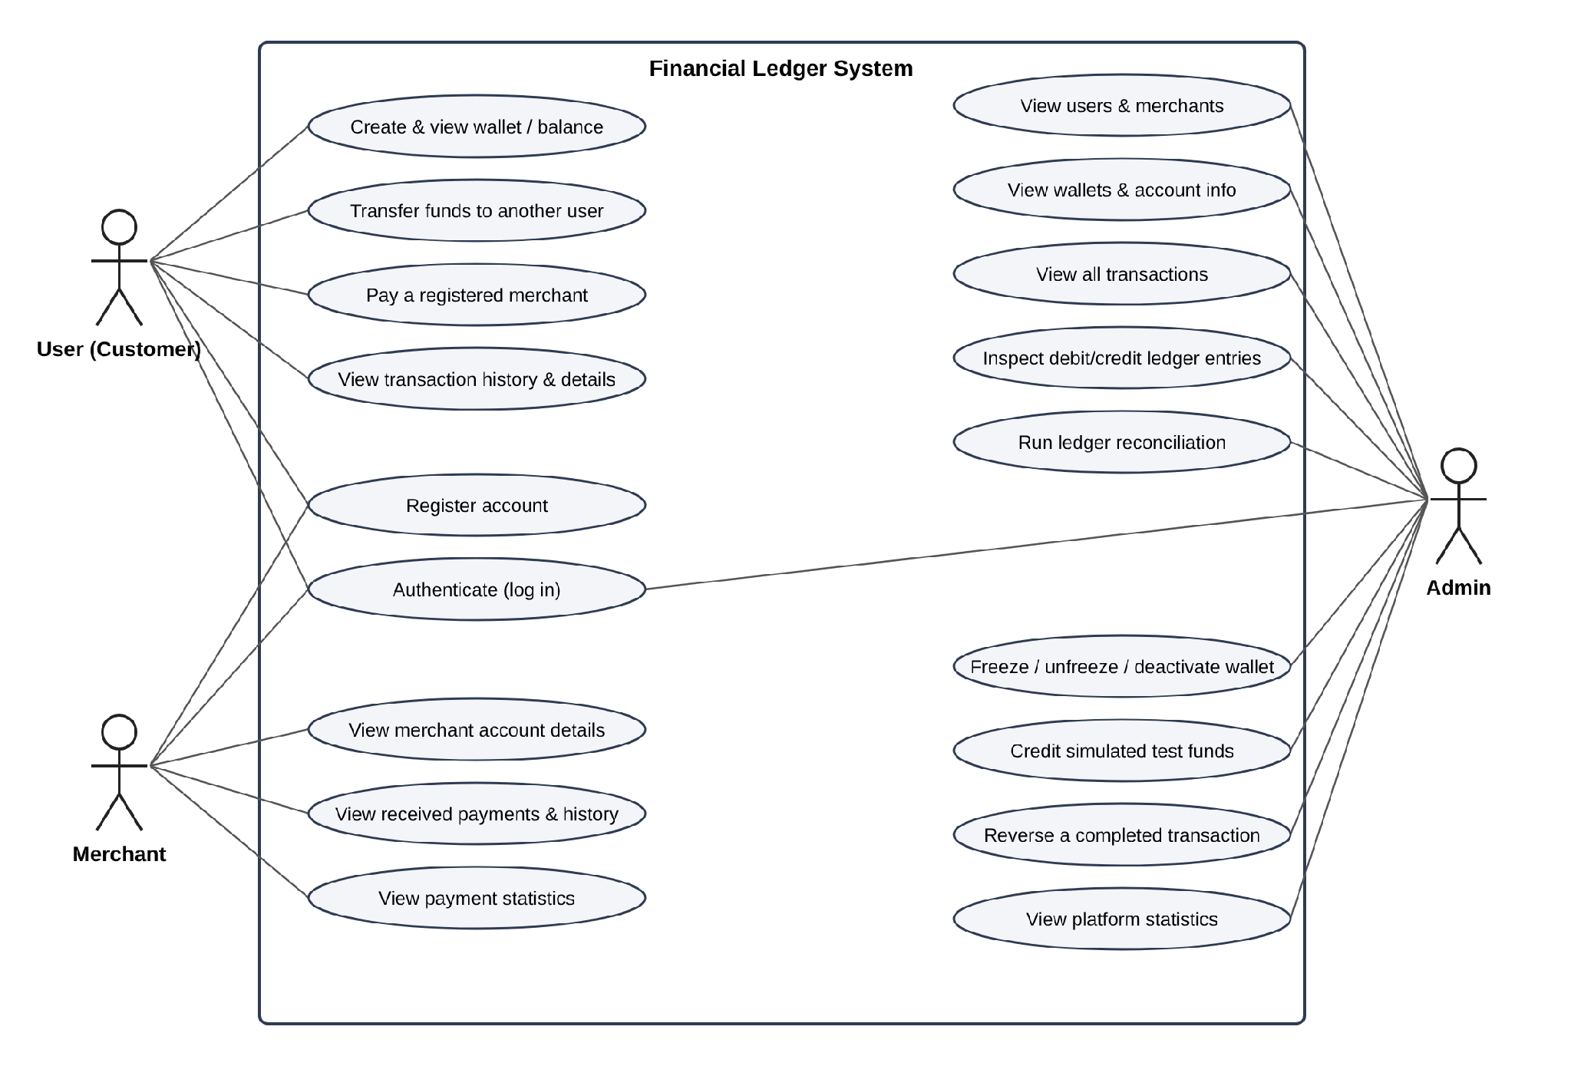
Figure B-1: Use case diagram

B.2 High-Level System Architecture
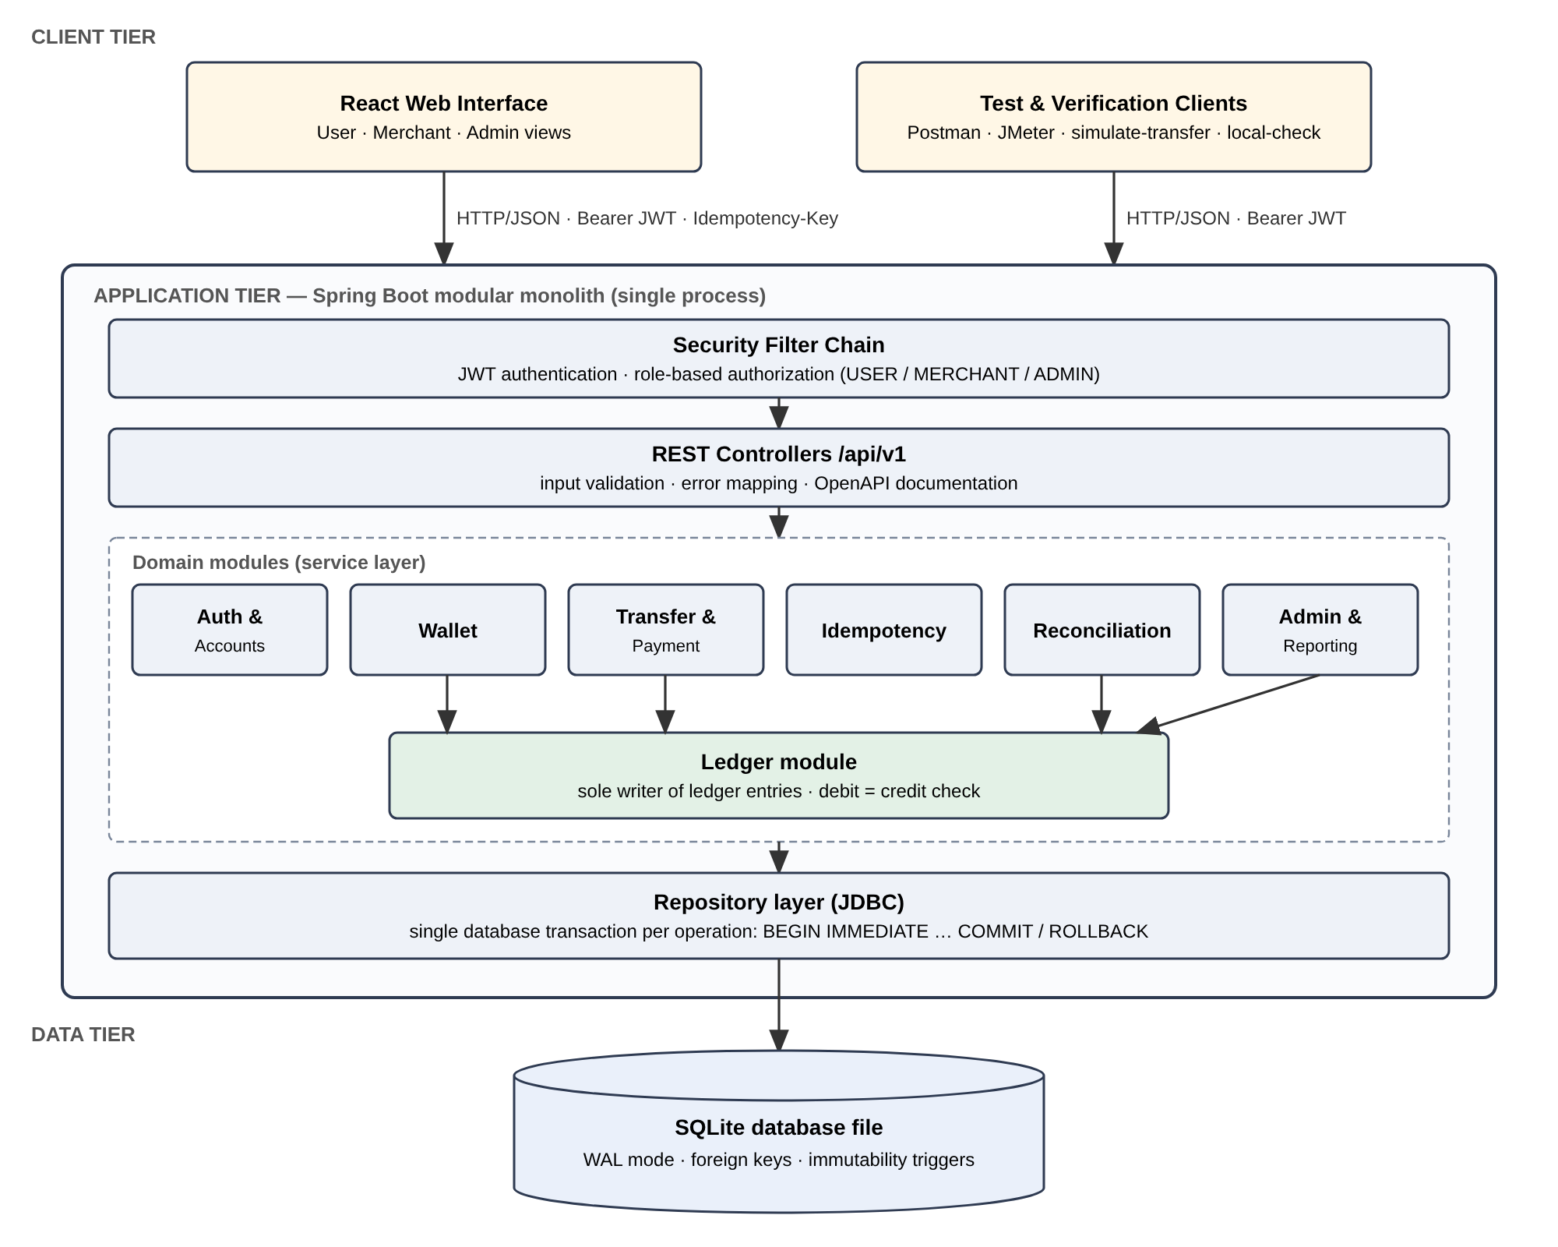
Figure B-2: Architecture — every money movement goes through the Ledger module in one SQLite transaction

B.3 Entity Relationship Diagram
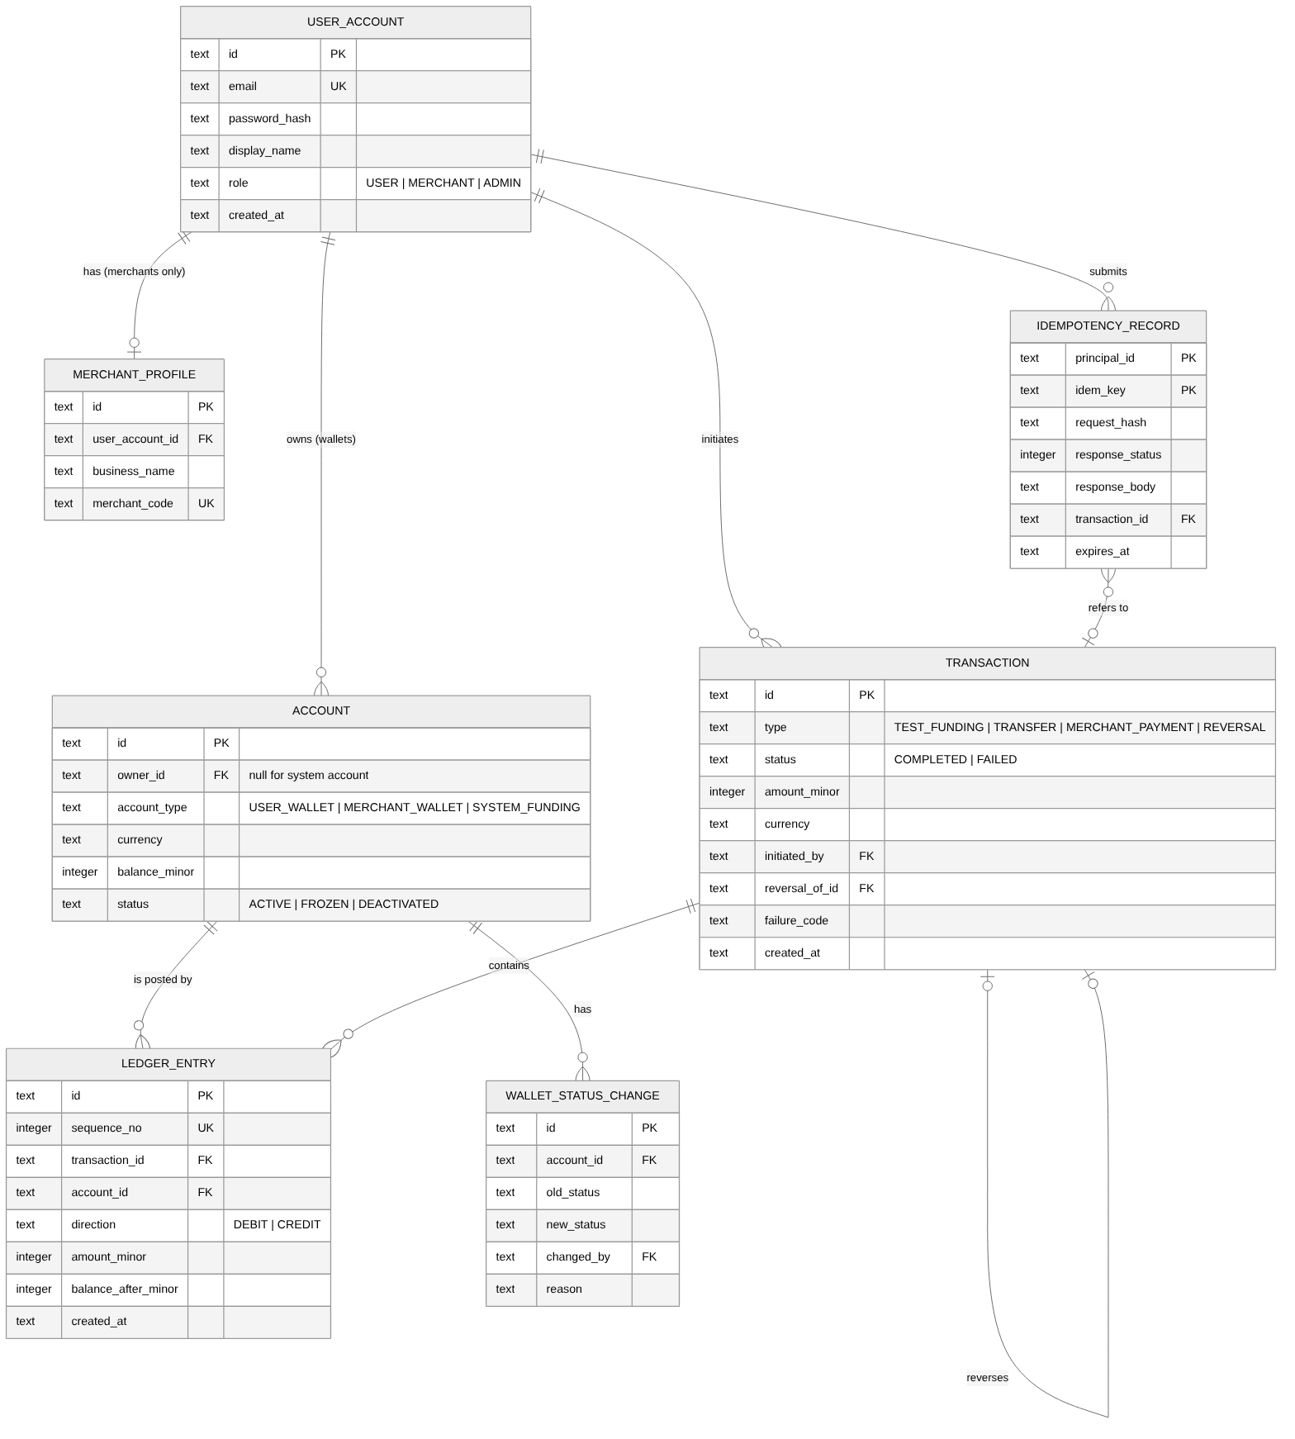
Figure B-3: Logical data model (ACCOUNT holds wallets and System Funding Accounts)

B.4 Transaction Lifecycle (Activity Diagram)
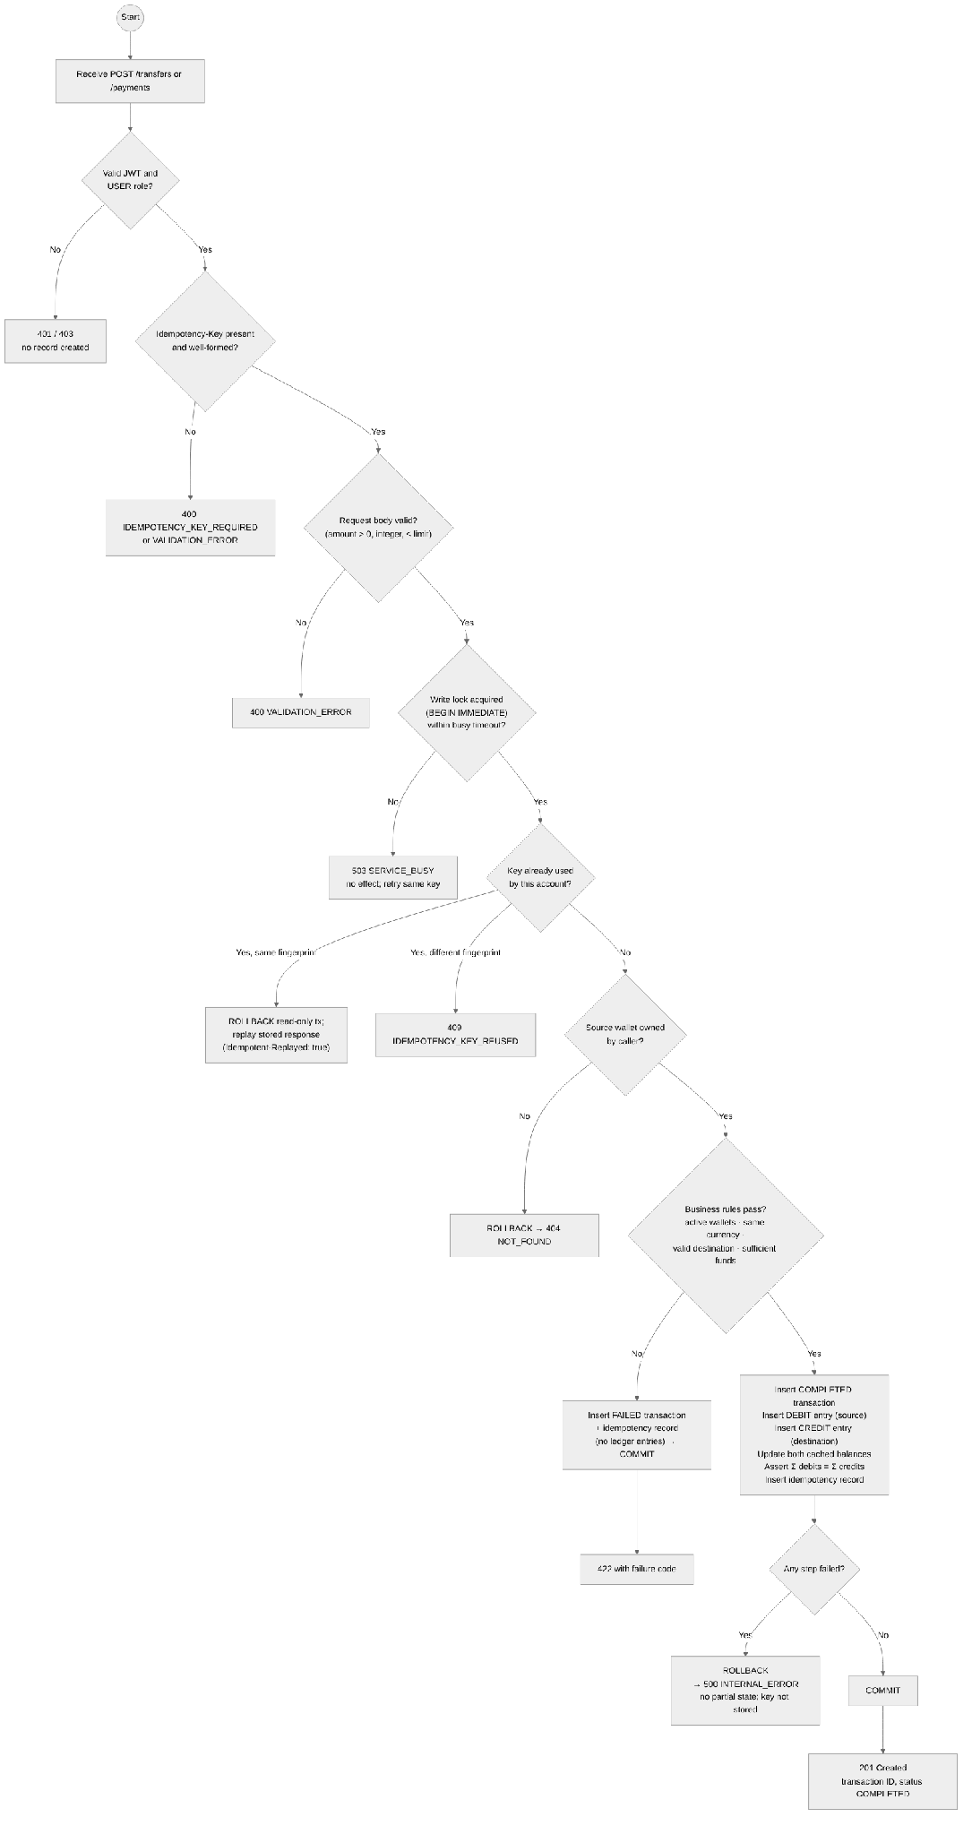
Figure B-4: Transfer / payment processing — a record is created directly as COMPLETED or FAILED

Appendix C: To Be Determined List
ID | Open item | Resolution
TBD-1 | Supported currencies besides INR (candidate: USD, to demonstrate distinct-currency wallets). | Decide in Stage 2; record as an ADR.
TBD-2 | Final per-transaction limit (default ₹1,00,000.00). | Confirm with instructor before Stage 2.
TBD-3 | Build tool (Maven or Gradle) used by local-check step 1. | Decide with the repository skeleton.

